Game Overview
Genre: Narrative-driven Detective Adventure
Perspective: First-person
Platform: PC / Console
Target Audience: Mature audiences (17+) fans of heavy story, mystery, moral dilemmas

🎯 Game Pillars
- Investigative and Puzzle-like Gameplay
  - Each case is a mystery requiring deductive reasoning, evidence analysis, interrogation, and logic puzzles.
- Morality-Based Choices
  - Players decide whether to act ethically or selfishly, directly influencing character relationships and reputation.
- Choices Affect Gameplay and Ending
  - Every decision echoes through the game: affecting skills, allies, enemies, and narrative resolution.

🧠 Core Concept
You play as a former police detective turned private investigator. Burned by a corrupt system, you're now free but morally adrift. Each case is a chance to do the right thing… or survive by bending the rules.
You choose your clients. Sometimes, they’re wolves in sheep’s clothing. The money is good, but the consequences may be devastating.
- 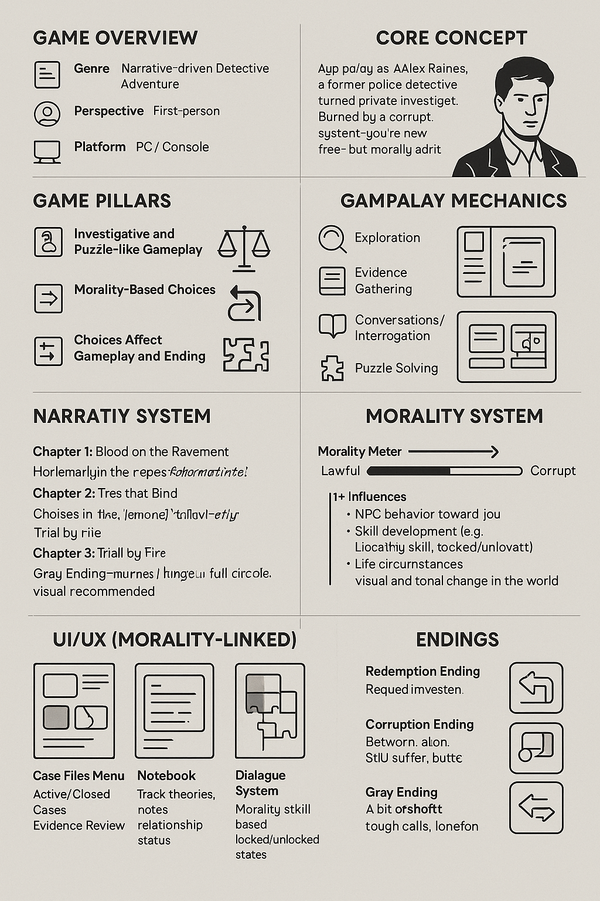

📚 Narrative Structure

Game is split into 3 Chapters
Each chapter includes 3 standalone cases, connected by an overarching story arc about a city on the brink rife with corruption, violence, and hidden power struggles.
- Chapter 1: Blood on the Pavement You're still learning the ropes. Morality feels flexible.
- Chapter 2: Ties that Bind Choices from Chapter 1 resurface. Allies and enemies begin to form.
- Chapter 3: Trial by Fire The consequences come full circle. All relationships and endings hinge on your past decisions.
Each case allows:
- Accept or refuse the client
- Choose methods: manipulation, honesty, intimidation, etc.
- Influence who lives, who dies, who gets justice

🔄 Case Progression & Personal Memory System
To enrich narrative immersion and emotional continuity, each completed case (or major investigative milestone) unlocks a “Memory Fragment.” These fragments are pieces of the protagonist’s forgotten, buried, or ignored past delivered through:
- Audio Logs (e.g., old voicemails, analog tapes, intercepted recordings)
- Handwritten Letters (e.g., from a sister, a former partner, or an anonymous observer)
- News Clippings & Case Files (from their time in the force or childhood events)
- Scraps from a Personal Journal (which updates depending on player decisions)
These fragments are not explicitly chronological, and some may seem disconnected until the player sees the emotional or thematic link to the case just solved.

🧠 Narrative Intent
These memories are:
- Tied emotionally or symbolically to the case just solved.
- Intentionally vague in pronouns or gender specifics but layered with suggestive detail, inviting the player to draw their own conclusions.
- Written to feel personal yet open, creating space for self-reflection and interpretation.
Example:
“You always hated lying. Even when you had to. Remember that time in the alley behind Pop's bar? You were what, nine? And you said you saw the man with the knife. But you didn’t. You just wanted to protect them. You always did.”
(– voice crackles faintly, feminine but maybe not?)

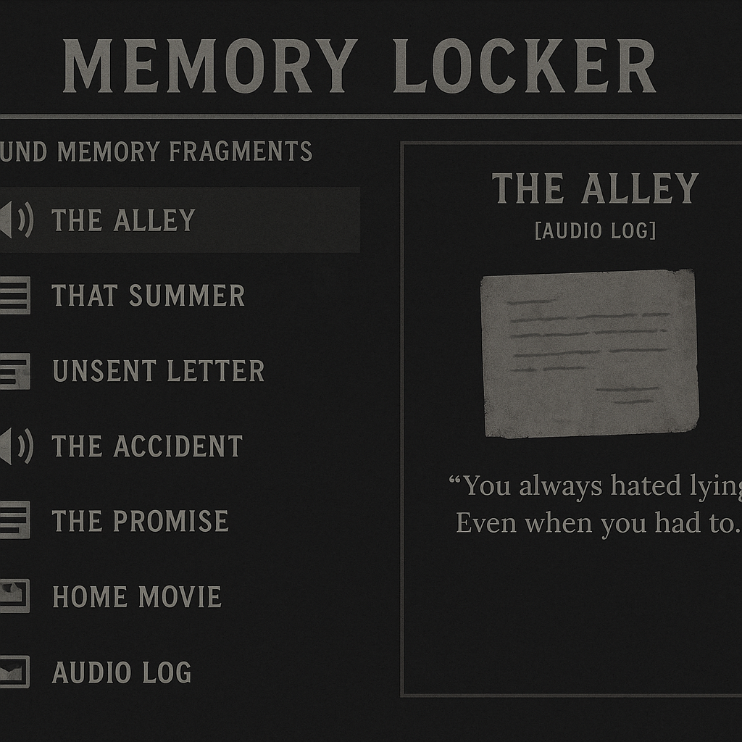

🔓 Gameplay Integration
- Triggered after each case resolution, either at the protagonist's home, in a hidden drawer, or while revisiting a location.
- Sometimes given as optional discoveries, encouraging exploration.
- Not all memories are warm. Some are jarring, cruel, confusing just like the cases themselves.
- Some contradict others, leaving the player to decide: which version of the past is real?

🎭 Emotional Function
- Builds identity ambiguity and lets players project their own understanding of the protagonist.
- Strengthens moral weight by drawing parallels between past and present behavior.
- Adds reactivity: Some fragments may change slightly depending on moral alignment reflecting a "distorted memory" effect (e.g., same tape, but dialogue alters if you're leaning corrupt).

📖 Memory Archive UI (Proposed Addition)
- Memory Locker section in the menu
  - Viewable audio logs and documents
  - Organizable by location/case link
  - Thematically dark, moody UI with shifting tones depending on alignment
  - Fragments titled vaguely (“The Alley,” “That Summer,” “Unsent Letter”) to maintain mystery

🕹️ Gameplay Mechanics

📂 Case Investigation
- Exploration: Move around crime scenes, offices, and public spaces.
- Evidence Gathering: Find clues using tools (UV light, recording devices, fingerprint kit).
- Conversations/Interrogation: Dialogue trees with unlockable options based on past actions & skills.
- Puzzle Solving: Unlock safes, piece together timelines, decrypt evidence.

🧭 Morality System
- Actions affect your Morality Meter (Lawful ⇆ Corrupt)
- Influences:
  - NPC behavior toward you
  - Skill development (e.g., High Corruption → unlocks blackmail, intimidation)
  - Life circumstances (family interactions, threats from criminal allies)
  - Visual and tonal changes in the world (city may grow darker or more hopeful)

🔓 Skill Tree (Morality-Linked)
- Negotiation
- Observation
- Interrogation
- Stealth
- Forensic Analysis
Different branches may unlock depending on your moral alignment.

🧍‍♂️ Characters

Protagonist: Alex Raines
- Customizable gender/name (optional)
- Backstory: Ex-cop with a family they’re trying to support or hide from.
- Inner conflict: Justice vs. Survival

Key Supporting Characters
- Clara Mendoza Journalist, potential ally/love interest (sensitive to morality)
- Detective Kwan Ex-partner, now rival. Helps or hinders based on your decisions.
- Client Pool: Cartel boss, grieving widow, crooked politician, scared teen each case has a unique flavor and moral test.

🧩 UI/UX
- Case Files Menu: Active/Closed Cases, Evidence Review
- Notebook: Tracks theories, notes, relationship status
- Dialogue System: Options colored/shaded based on morality skill, locked/unlocked states
- Morality Bar: Visual tracker but not numerical (keeps it immersive)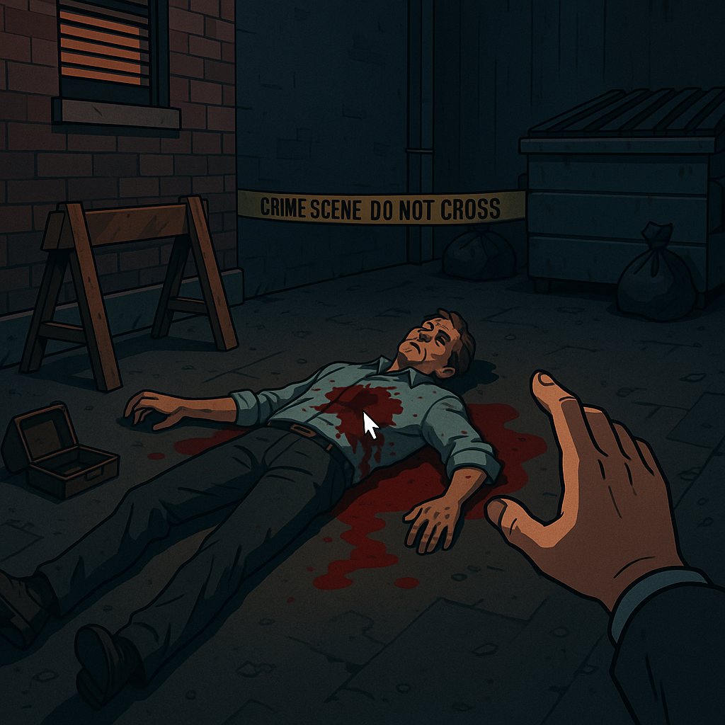

🏁 Endings
At least 3 Major Endings, plus minor variations:
- Redemption Ending You played it mostly clean. You earned respect. You still suffer, but the city has hope.
- Corruption Ending You’re powerful. Feared. Alone. The system works for you now but at what cost?
- Gray Ending A bit of both. The system remains murky. You made tough calls. You sleep at night… sometimes.

🎨 Art & Aesthetic
- Neo-noir gritty realism
- Visual cues for morality:
  - Lawful = Brighter environments, hopeful music
  - Corrupt = Dingier textures, echoing sounds, NPCs act colder
- Voice acting highly recommended for immersion

🛠️ Future Considerations
- DLC: Additional chapters with new cases
- Optional randomized case generator (after main story/ extra hard difficulty new game)
- Steam Achievements or moral profiles at the end

👣 Next Steps
If this feels on the right track, we can move to:
- Deep-dive into each chapter's case outlines
- Sample character arcs
- Visual UI mockups
- Dialogue system framework
- Puzzle examples and case mechanics

